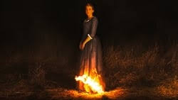HFS Film Club – talking points

*Portrait of a Lady on Fire*

Dir: Celine Sciamma

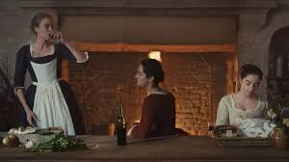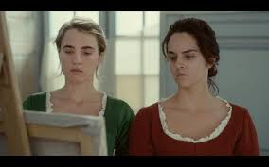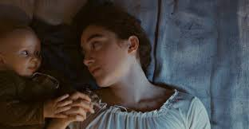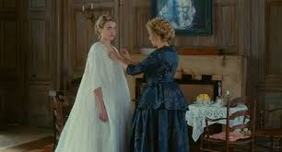

As a female French film director, what ideas, and critiques, of ‘liberté, égalité, fraternité’ (1772) does Sciamma pose in the film for a modern audience?

What associations with, and ideas of, fire are suggested through the film?

What other ‘readings’ or interpretations of the film might they signify?

‘This film is a lesson on the subversion of the 'scopophilic' (gaining pleasure from looking) tendencies of the male-gaze and the eradication of power imbalance which comes with sexual difference.’

How far do the camera shots and composition support this assessment?

How effective is Sciamma’s use of Orpheus and Eurydice as a motif to explore ideas of love and autonomy?